Department of Information Technology

Semester: V Name of Student:
Academic Year: 2022-23 Student ID:
Class / Branch: TE IT
Subject: Security Lab (SL)
Name of Instructor: Prof. Apeksha Mohite

EXPERIMENT NO. 3A

Aim: To Study use of Iptables to configure stateful Software firewall on Linux Host.
Making default policy of INPUT and OUTPUT Chain as DROP :
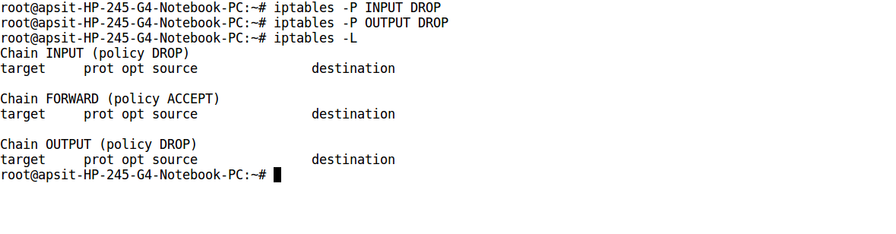
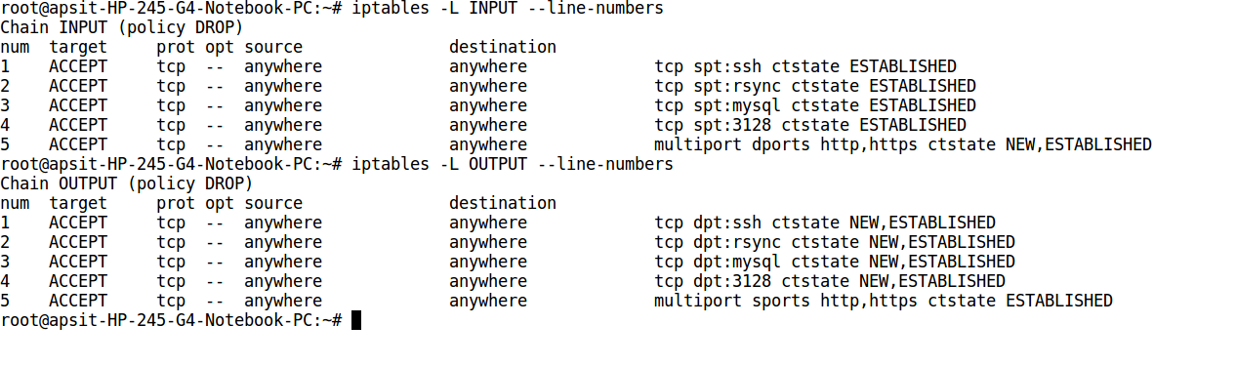
Listing Rules in INPUT and OUTPUT Chain :
Testing Outgoing Connections of SSH, Mysql, Rysnc, Squid :
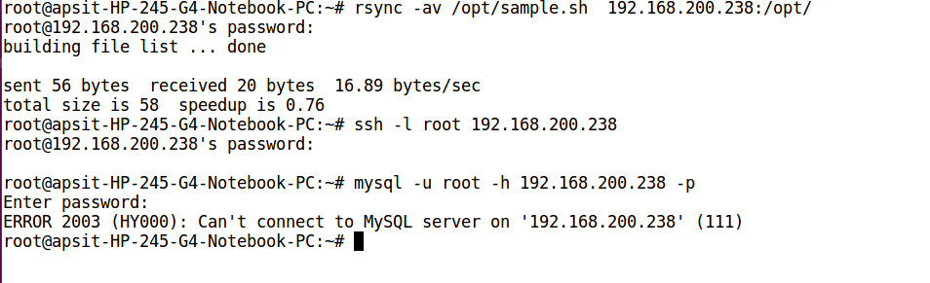
Testing Incoming Connections of HTTP, HTTPS :
